Exchequer Enterprise

User Defined Field Hook

Introduction
The User Defined Field Hook is designed to allow customers to add simple validation to the User Definable fields within Enterprise.
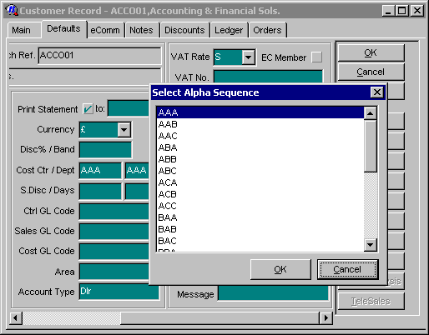

When the user exits each field a popup list can be displayed for the user to select an entry:-

Once an entry has been selected, the text is placed into the User Definable field and the user can carry on as normal.

The popup list is available on the Customer, Supplier, Job, Stock Transaction Header and Transaction Detail windows.

Configuration

There is a program supplied that you can use to configure the user-defined field hook. The file is USERHADM.EXE and when you run it you should be presented with a screen like this :
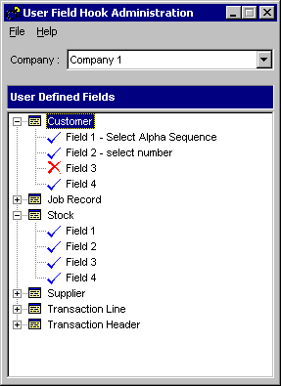

You can select a specific company to edit the configuration of, and then double click on the required field to edit the configuration of that field. You will then be shown a dialog as follows.
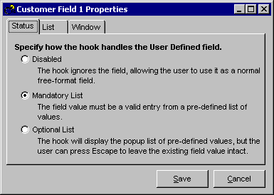

The options in the status tab are already described for you in the dialog. If you select one of the 'list' options you can then gain access to the other tabs :

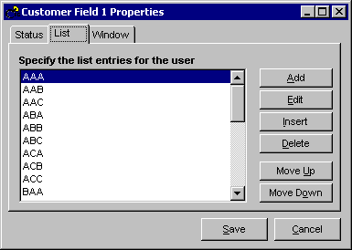
The list tab configures the list of options that you will be prompted with, when the hook fires,

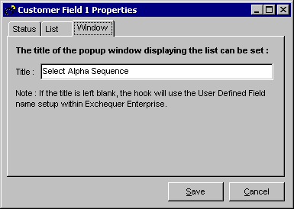
and the Window tab allows you to specify the name of the window that appears.

Click on 'Save' to save the changes that you have made to the configuration of the user defined field.

Installation
The installation routine differs depending on which version of the User Defined Field Hook you are going to use.

Installing the COM Client
- Copy the following supplied files into your Exchequer Enterprise v4.31 directory:-

UserHadm.Exe
EntUserF.Exe
EntUserF.Ini

- In the Enterprise directory, edit EntCustm.Ini and add the following section:-

[COMClients]
1="X:\Exch\Entrprse\EntUserF.exe"

If this section already exists then just add the second line into the pre-existing section with the next available number.

- Run Enterprise and scroll down in the Help + About dialog, you should see the following text:-

Enterprise User-Defined Field Hook
Version 4.31.002/COM
Copyright 1986-2000 Exchequer Software Ltd

The presence of this text indicates the hook is working and you can proceed, if this text is not present then something has gone wrong in a preceding step.

- Read the preceding section ‘Configuration’ and setup the hook as required.

Installing the Delphi DLL
- Copy the following supplied files into your Exchequer Enterprise v4.31 directory:-

UserHadm.Exe
EntUserF.Dll
EntUserF.Ini

- In the Enterprise directory, edit EntCustm.Ini and add the following section:-

[HookChain]
ENTCUSTM=ENTUSERF

If an ‘ENTCUSTM=’ entry already exists then contact your technical support for advice.

- Run Enterprise and scroll down in the Help + About dialog, you should see the following text:-

Enterprise User-Defined Field Hook
Version 4.31.002/DLL
Copyright 1986-2000 Exchequer Software Ltd

The presence of this text indicates the hook is working and you can proceed, if this text is not present then something has gone wrong in a preceding step.

- Read the preceding section ‘Configuration’ and setup the hook as required.

EntUserF.INI
All the settings for the User Defined Field Hook are stored in EntUserF.Ini in the Enterprise directory. There is one section per user defined field stored in the following format:-

[CustUser1]
Enabled=1
Enforced=1
WindowCaption="Customer User Def 1"
ListItemCount=5
ListItem1="AAA"
ListItem2="AAB"
ListItem3="AAC"
ListItem4="ABA"
ListItem5="ABB"

The Enabled entry is used to enable the popup list for the field:- 0=Disabled (Default), 1=Enabled.

The Enforced entry indicates whether the field has to contain a valid entry from the list, if set as optional (0) then the user can press the cancel button to close the dialog, leaving the user defined field unchanged. If enforced (1) then Enterprise will treat leaving the list without selecting a valid item as a validation error and return the user to the list.

WindowCaption is an optional entry and allows the Title of the popup window to be specified. If not specified the Title will be set to ‘Select’ followed by the name of the user defined field.

The ListItemCount field specifies how many ListItem entries are defined for the list. Each ListItem entry defines a piece of text that will be shown as-is in the popup list.

Section Titles
The following section titles should be used:-

[CustUser1] | User Defined Field 1 in the Customer window
[CustUser2] | User Defined Field 2 in the Customer window
[CustUser3] | User Defined Field 3 in the Customer window
[CustUser4] | User Defined Field 4 in the Customer window
[JobUser1] | User Defined Field 1 in the Job window
[JobUser2] | User Defined Field 2 in the Job window
[LineUser1] | User Defined Field 1 in the Transaction Line window
[LineUser2] | User Defined Field 2 in the Transaction Line window
[LineUser3] | User Defined Field 3 in the Transaction Line window
[LineUser4] | User Defined Field 4 in the Transaction Line window
[StockUser1] | User Defined Field 1 in the Stock window
[StockUser2] | User Defined Field 2 in the Stock window
[StockUser3] | User Defined Field 3 in the Stock window
[StockUser4] | User Defined Field 4 in the Stock window
[SuppUser1] | User Defined Field 1 in the Supplier window
[SuppUser2] | User Defined Field 2 in the Supplier window
[SuppUser3] | User Defined Field 3 in the Supplier window
[SuppUser4] | User Defined Field 4 in the Supplier window
[TransUser1] | User Defined Field 1 in the Transaction Header window
[TransUser2] | User Defined Field 2 in the Transaction Header window
[TransUser3] | User Defined Field 3 in the Transaction Header window
[TransUser4] | User Defined Field 4 in the Transaction Header window

